Video helps

Motor-relay connection

<https://www.youtube.com/watch?v=Z0SZ-jzu_q8&t=59s>

Rain sensor- servo motor

<https://www.youtube.com/watch?v=RxWD_-h7O8Y>

Rain sensor- servo motor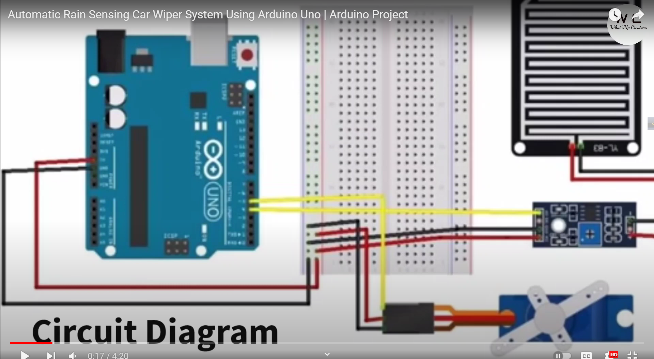

ultrasonic -servo motor-led.

Which help me to understand the ultrasonic mechanism

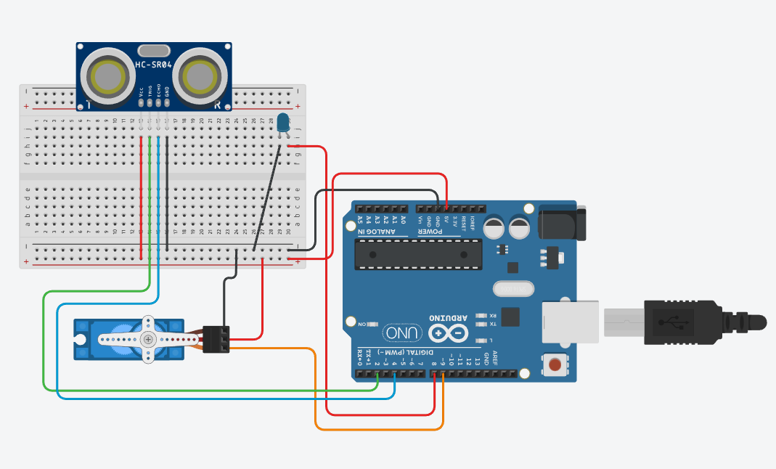

//For this code:

#define trig 2

#define echo 4

#define led 8

//Servo

#include <Servo.h>

Servo gate;

void setup() {

Serial.begin(9600);

pinMode(trig, OUTPUT);

pinMode(echo, INPUT);

pinMode(led,OUTPUT);

gate.attach(9);

}

void loop() {

//ultra sonic sensor

digitalWrite(trig,LOW);

delayMicroseconds(2);

digitalWrite(trig,HIGH);

delayMicroseconds(10);

digitalWrite(trig,LOW);

long t =pulseIn(echo,HIGH);

long cm = t /4 / 2;

Serial.print(cm);

Serial.println("cm");

//led

if (cm <=19){

digitalWrite(led, HIGH);

}

else{

digitalWrite(led,LOW);

}

//Gate

gate.write(170);

if (cm<= 19){

for( int j=170;j>=90;j--){

gate.write(j);

delay(50); //gate speed//90 degree

}

delay(5000); //gate opening delay time

for( int i=90;i<=170;i++){

gate.write(i);

delay(50);

}

}

else{

gate.write(170);

}

}

Final connection for code: 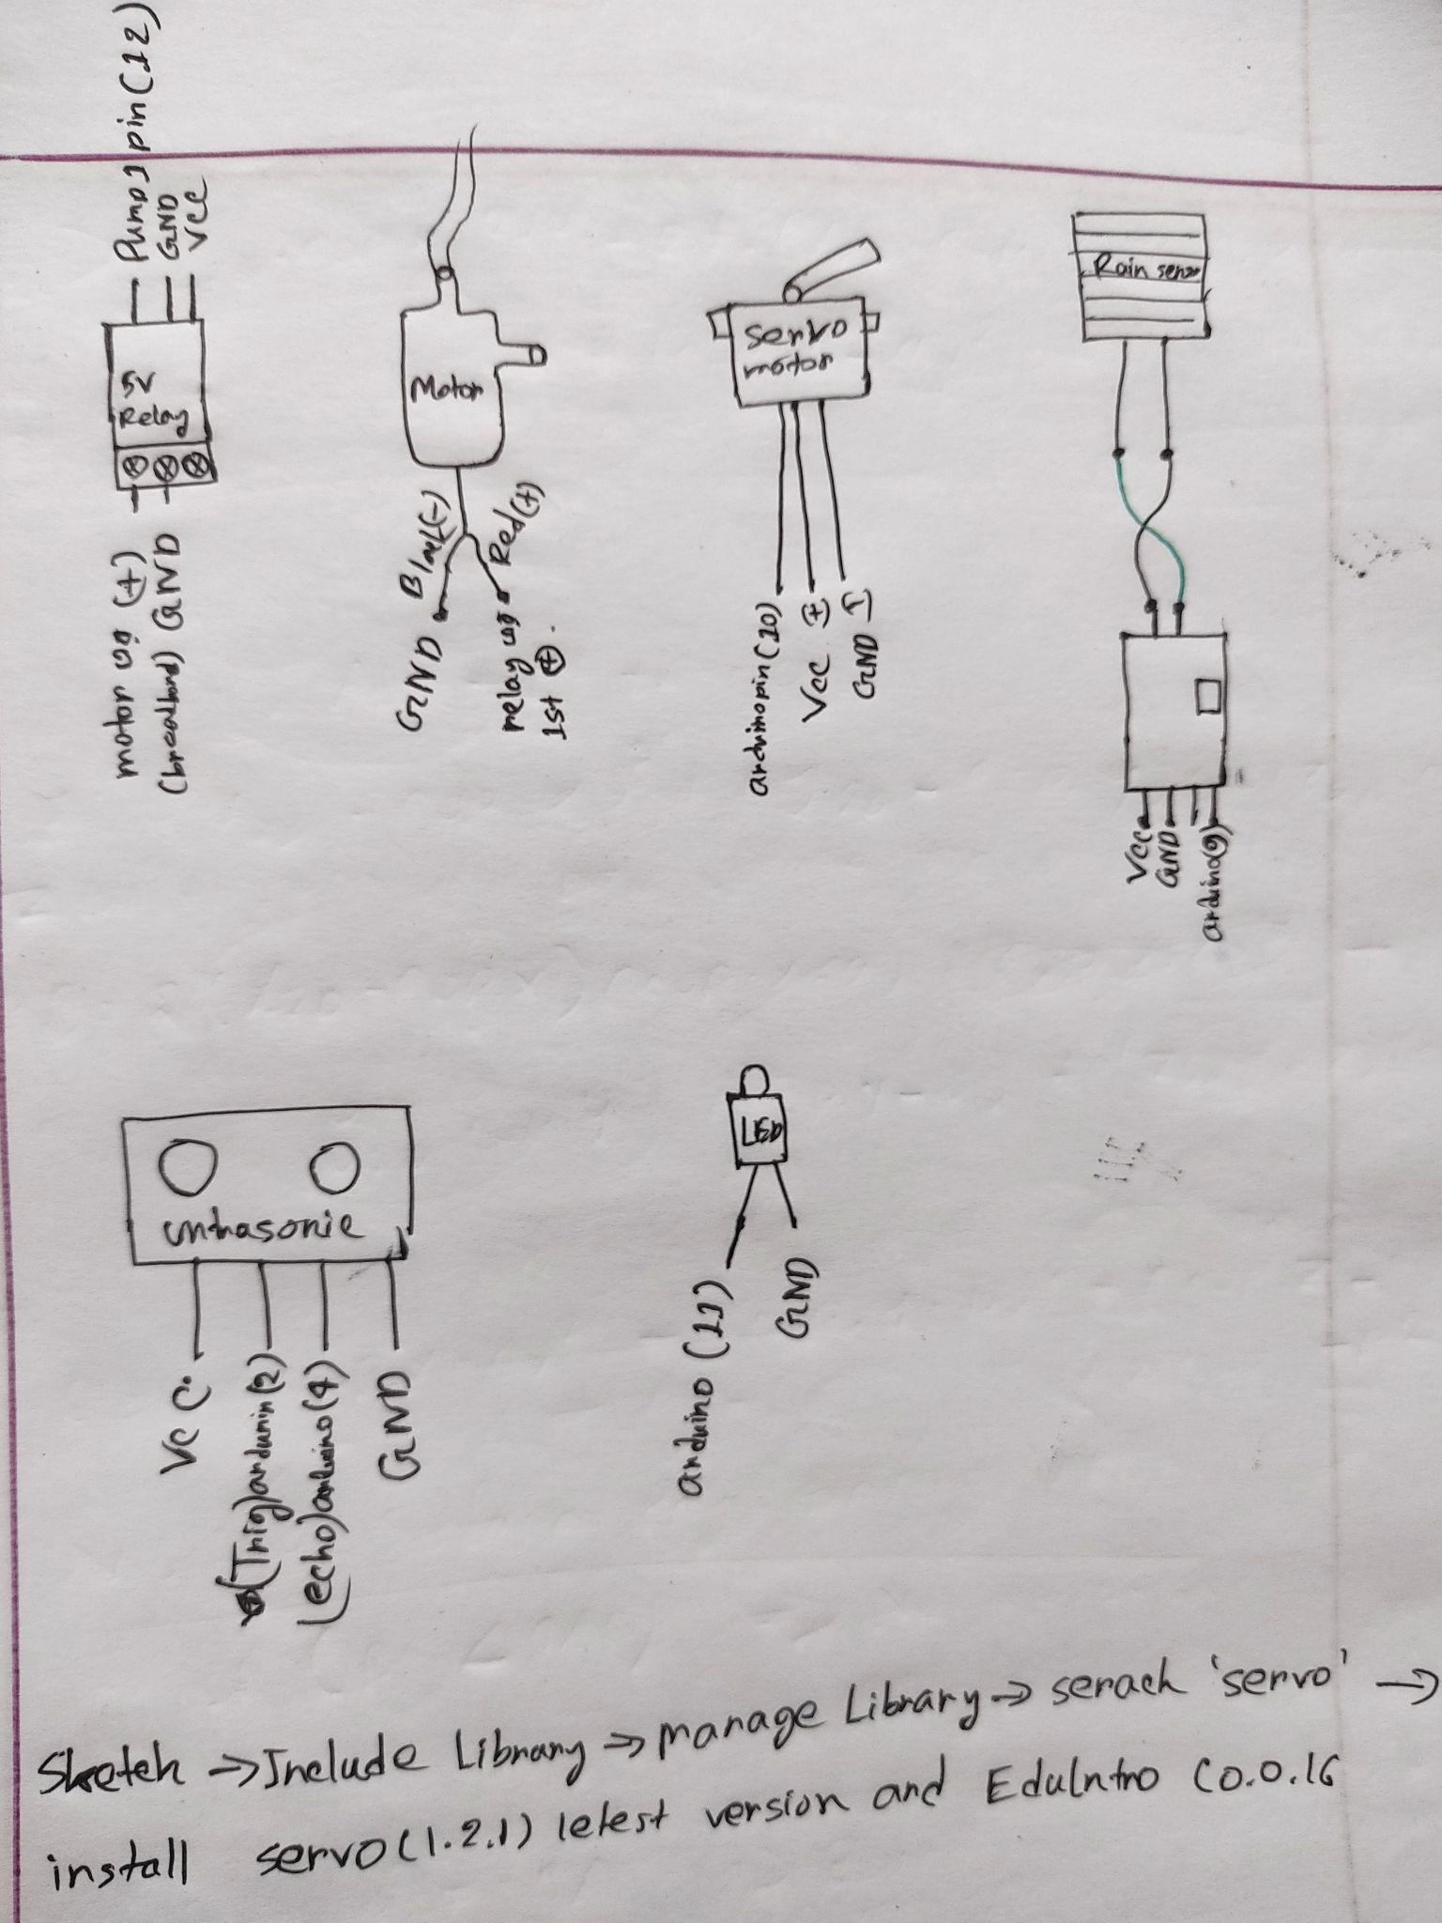

mechanism:

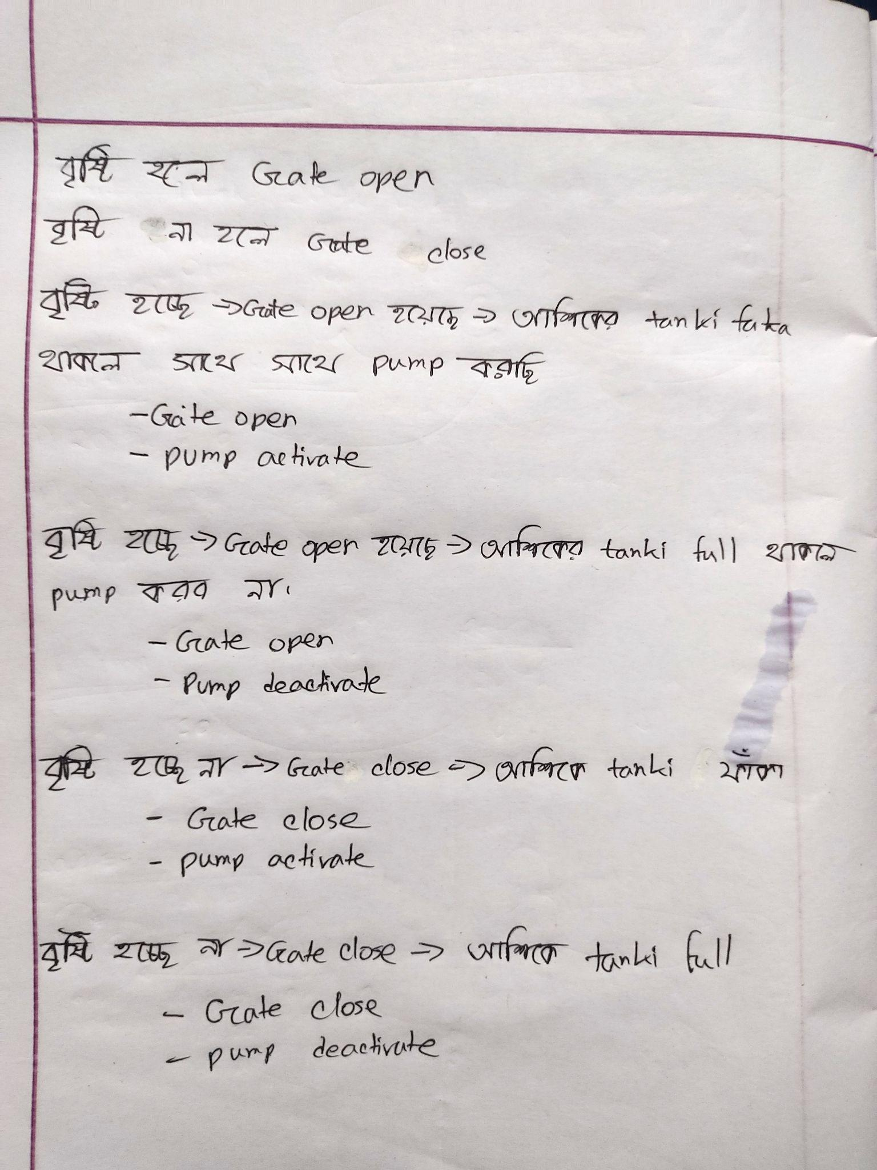

// Final code:

#include <Servo.h>

#include <Servo.h>

Servo tap_servo;

int rainsensor_pin = 9; //4

int tap_servo_pin =10; //5

int rainsensor_digital_value;

int trig=2;

int echo=4;

#define led 11

byte pump1 = 12;

long timeInMicro;

long distanceInCm;

void setup()

{

Serial.begin(9600);

pinMode(2,OUTPUT);

pinMode(4,INPUT);

pinMode(rainsensor_pin,INPUT);

tap_servo.attach(tap_servo_pin);

while (!Serial);

pinMode(pump1, OUTPUT);

pinMode(led,OUTPUT);

}

void loop()

{

rainsensor_digital_value = digitalRead(rainsensor_pin);

digitalWrite(trig,LOW);

delayMicroseconds(2);

digitalWrite(trig,HIGH);

delayMicroseconds(10);

digitalWrite(trig,LOW);

timeInMicro= pulseIn(echo,HIGH);

distanceInCm = ((timeInMicro/29)/2);

Serial.println(distanceInCm);

delay(100);

if (rainsensor_digital_value==1){

tap_servo.write(180); // gate off // bristi na hole gate always off

}

if (rainsensor_digital_value==0 ){

tap_servo.write(0); // gate open // bristi na hole gate always open

}

if (rainsensor_digital_value==1 && distanceInCm >=4){

tap_servo.write(180); // gate off

digitalWrite(pump1, LOW); // pump1 activated //

digitalWrite(led, HIGH); // light activated

}

else if (rainsensor_digital_value==1 && distanceInCm <3){

tap_servo.write(180); // gate off // rain na hole gate always e off thakbe e

digitalWrite(pump1, HIGH); // pump1 deactivated // tanki full. so pump off

digitalWrite(led,LOW); // light deactivate

}

if (rainsensor_digital_value==0 && distanceInCm >=4){

tap_servo.write(0); // gate open // rain hocce and ashik er tanki o faka so sathe sathe e tar tanki te nia jabo

digitalWrite(pump1, LOW); // pump1 activated

digitalWrite(led, HIGH); // light activated

}

else if (rainsensor_digital_value==0 && distanceInCm <3){

tap_servo.write(0); // gate open

digitalWrite(pump1, HIGH); // pump1 deactivated

digitalWrite(led,LOW); // light deactivate

}

}